

12 PHYSICS

INDUCED EMF &
POWER TRANSMISSION
INDUCED EMF

Michael Faraday discovered that when a conductor is moved in a magnetic field, an electromotive force (EMF) is set up within it.

Each of the free-moving electrons inside the metal has its own small magnetic field. This interacts with the external magnetic field (which is changing due to the movement of the conductor), causing a force to be exerted on them. Hence the electrons flow as a current in one direction.

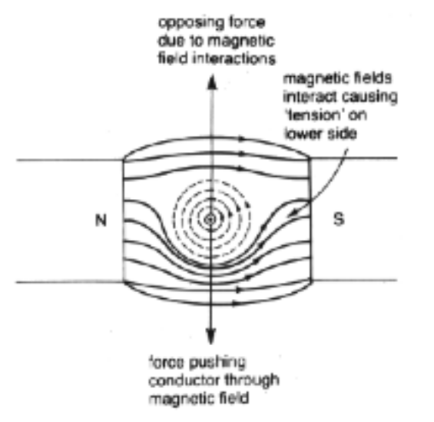

The key point is the changing magnetic field - if the magnetic field stops changing (i.e. the conductor stops moving), so too does the current stop.

The induced current produces a magnetic field that interacts with the external field. The resulting force opposes the motion of the conductor.

Work has to be done to keep the conductor moving, and this work is seen as electrical energy in the conductor.

i.e. Mechanical work is transformed into electrical energy.

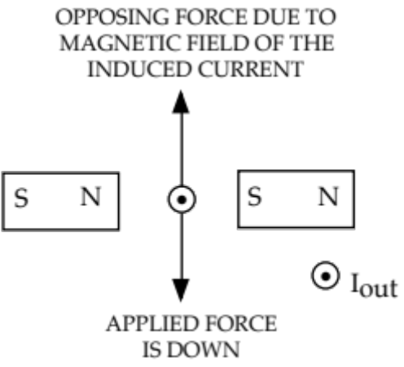

The direction of the induced current is given by the “right hand rule” - fingers in the direction of B; palm in the direction that opposes the motion of the conductor; thumb points in the direction of the induced conventional current I.

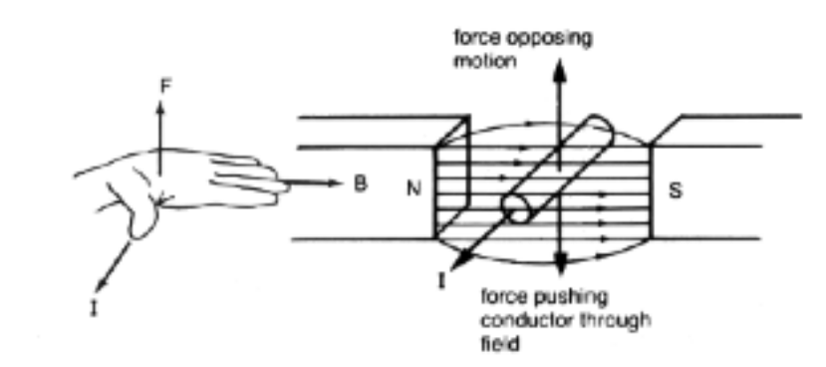

The production of an opposing force is summed up in Lenz’s Law.

Lenz’s Law: An induced current will be in such a direction as to produce a magnetic force
that opposes the change causing it.

Examples
1. Apply Lenz’s Law to each of the following situations.

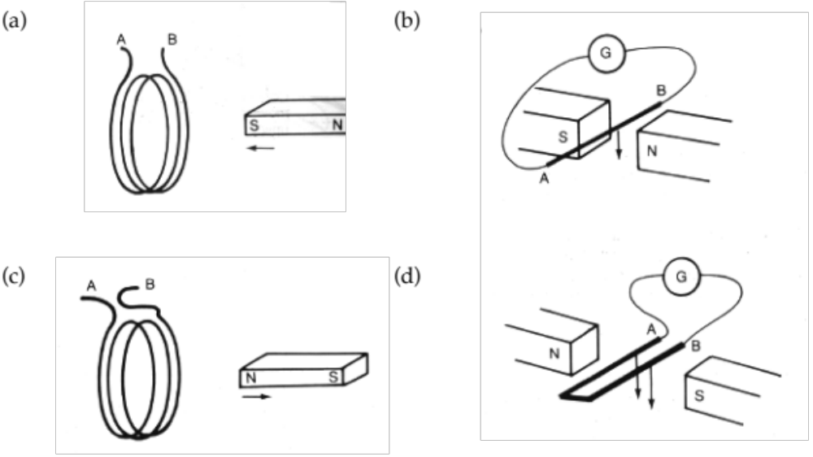
2. A magnet is dropped through the core of a solenoid as shown. Graph (without calculation)
the induced current produced in the coil.

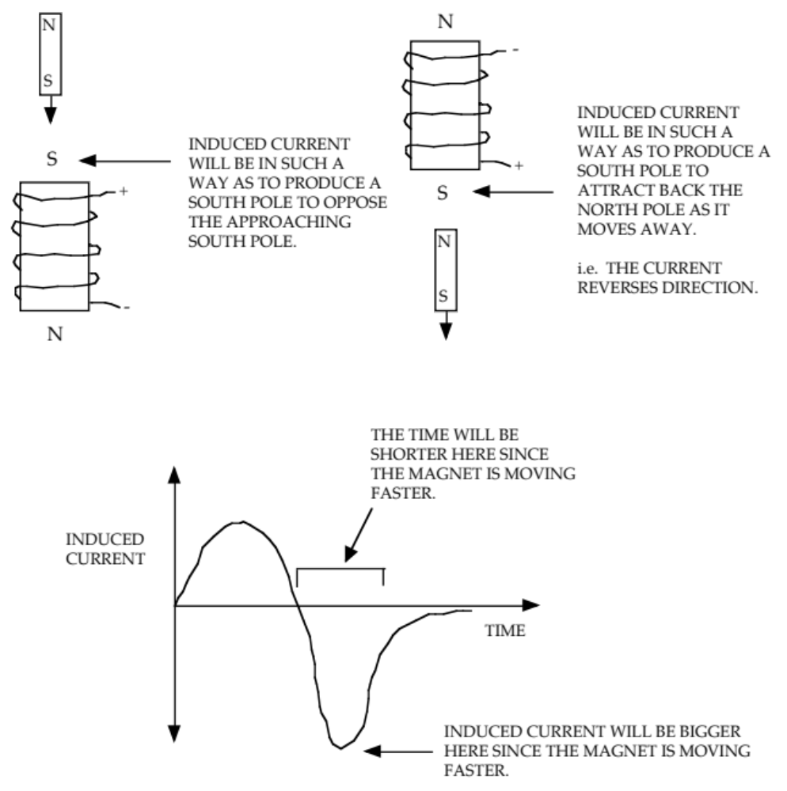

3. A rectangular copper coil ABCD is attached by a string to a support so that it can swing
like a pendulum through a magnetic field as shown. The coil is initially released as shown
in (a) and allowed to swing through the field. Draw in the direction of the induced currents.

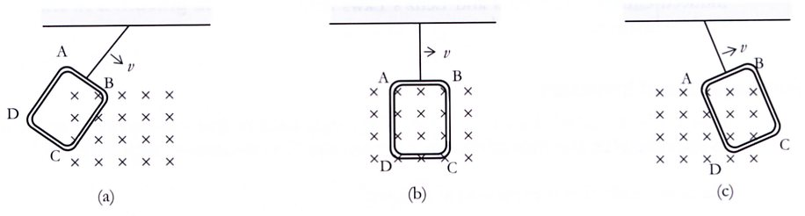
INDUCED EMF IN A SINGLE CONDUCTOR

For a single conductor moving through a magnetic field, the induced EMF is given by:

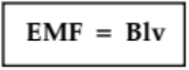

where EMF = the induced EMF across its ends (V).
B = the magnetic field strength (T).
l = the length of conductor cutting flux lines (m).
v = the velocity of the conductor through the field (ms-1).

B, l and v are always at right angles to each other.

If any two of them are parallel to each other, then EMF = 0.

If any two are at an angle to each other (but not 90°), then a component will need to be used.

From this relationship, EMF can be increased by:

1. increasing the velocity of the conductor through the magnetic field.
2. increasing the magnetic field intensity.
3. increasing the length of wire cutting the magnetic flux lines.

If the ends of the conductor are connected in a circuit, the induced EMF will produce a current flow (though it will fluctuate with the speed and magnetic field intensity).

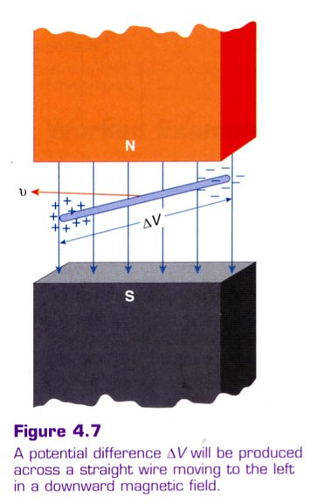
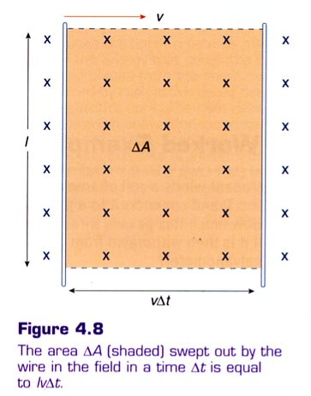
For a single conductor cutting a magnetic field at right angles, it
sweeps an area given by:

ΔA = l x vΔt

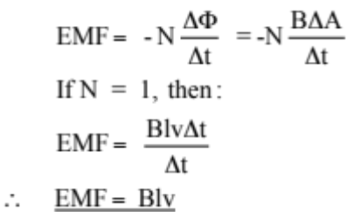

Example 1
A yacht with a 6.00 m high mast is sailing at 4.00 ms⁻¹ due west in the Southern Hemisphere where the Earth’s magnetic field intensity is 4.95 x 10⁻⁵ T at 54.0° dip.

(a) Calculate the EMF induced across the ends of the mast.
(b) Determine which end of the mast is the positive end.

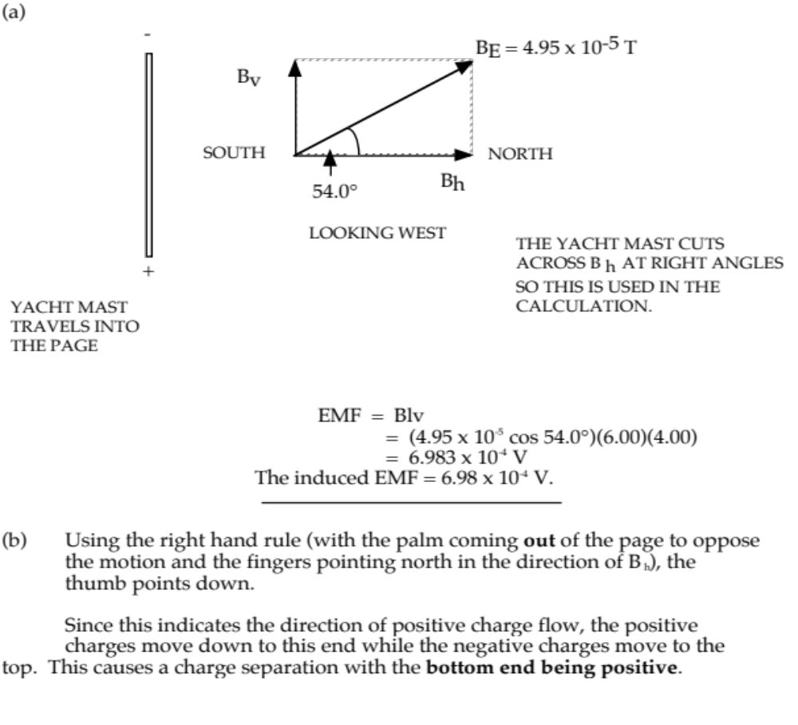
Example 2

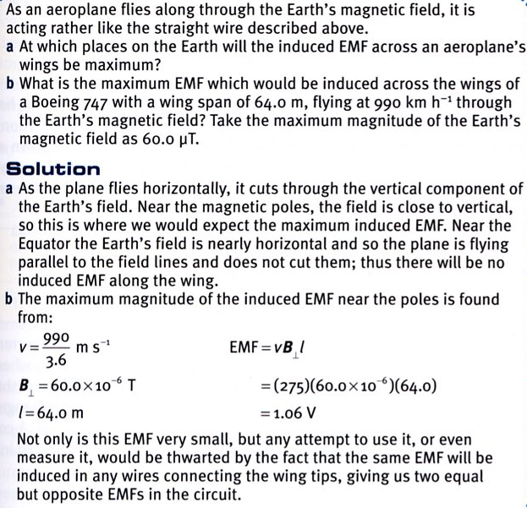

Law of Induction

Faraday demonstrated that an induce EMF is produced when magnetic flux lines are cut per unit time.

Faraday’s Law Of Induction: The size of the induced EMF depends on the rate of change of
magnetic flux linked with the coil.

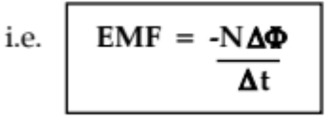

where EMF = the induced EMF (V).
N = the number of loops in the coil.
ΔΦ = the change in flux (Wb).
Δt = the time in which the change takes place (s).

Note
The negative sign shows the relative direction of the induced EMF and is related to the laws of energy conservation.

ΔΦ/Δt is called the flux linkage or rate of change of magnetic flux. It is a measure of how many flux lines are cut by the conductor per unit time.

An induced EMF is produced by:

• a wire or coil moving through a magnetic field.
(The more loops in the coil, the greater the induced EMF.)

• moving a magnet in relation to a stationary wire or coil.

• varying the magnetic field strength to alter ΔΦ/Δt.

No induced current is produced when:

• the conductor is stationary.

• the conductor moves parallel to the magnetic field.

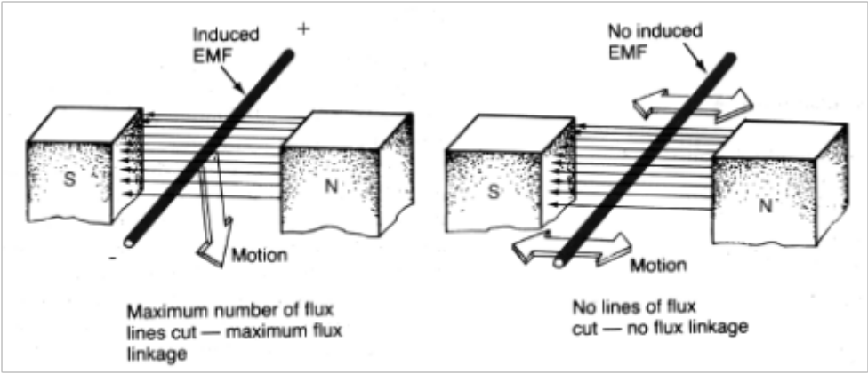
Examples

1. (Electrical Generator)
A coil of dimensions 20.0 cm x 10.0 cm and containing 200 loops is pivoted along its long
axis in a horizontal magnetic field of 0.342 T. It is rotated at 30.0 r.p.m. Calculate the
maximum EMF generated by the coil.

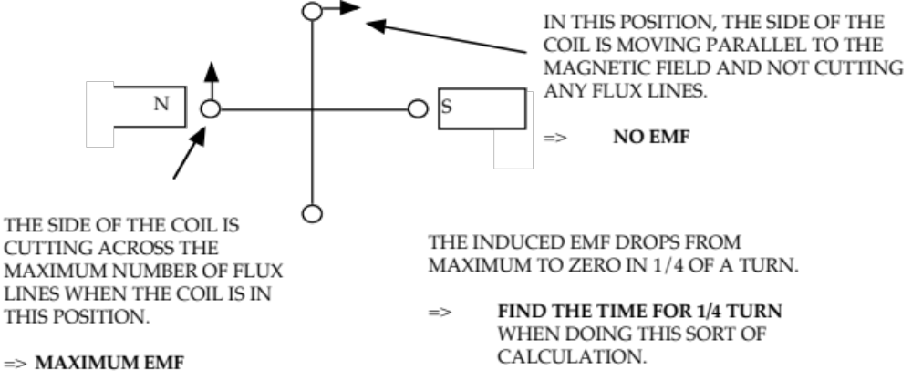

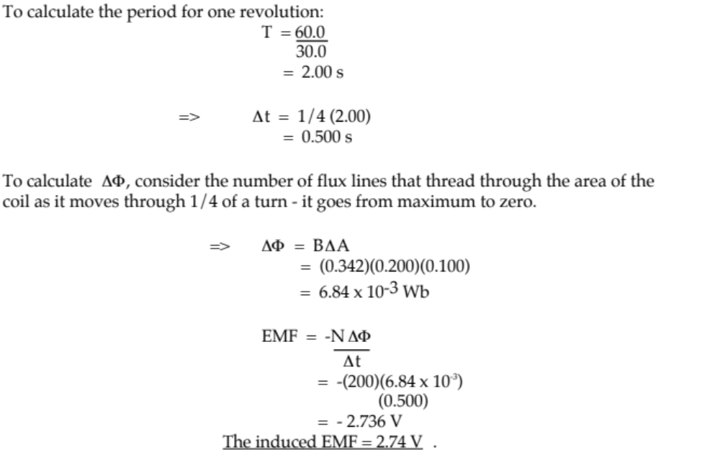

Note
This equation gives the average EMF generated in the coil, since the edge of the coil moves from cutting the maximum number of flux lines (max EMF) to cutting no flux lines (zero EMF).
Following is the derivation of the equation to give the maximum or instantaneous EMF in a rotating coil, taking into account its position relative to the magnetic field.

Consider the rotation speed of the coil. It is represented by the angular speed ω, which is measured in radians s⁻¹.

i.e. If the angle θ is the angle of the coil to the vertical:

θ = ωt

The amount of flux threading through a coil is given by:

φ = BA cosθ
= BA cos ωt

Using Calculus, the EMF induced due to the rate of change of the flux through the coil is given by:

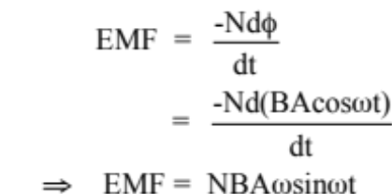

One complete revolution can be thought of as:

θ = 360° = 2π radians

The time taken for one revolution is the period T, and the frequency of the rotation is given by:

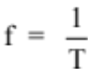.

∴ 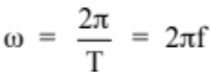

∴ EMF = NBA2πfsinθ

w θ = the angle of the coil to the vertical.

2. Microphone and Guitar String
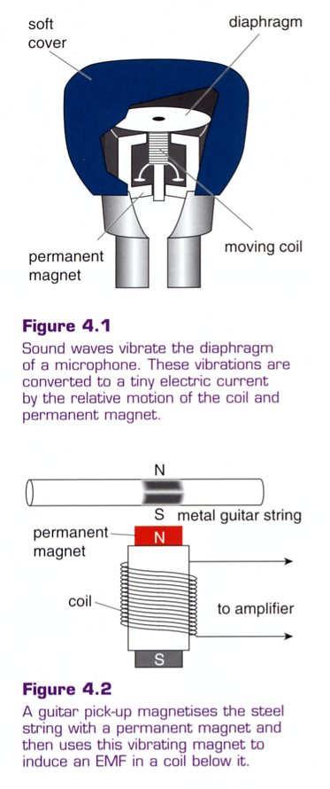
The function of a microphone is to convert sound
vibrations into electrical signals.

The so-called ‘dynamic’ microphone uses a tiny coil
attached to a diaphragm, which vibrates with the sound.

The coil vibrates within the magnetic field of a permanent
magnet, thus producing an induced EMF that varies with
the original sound.

The electric guitar uses electromagnetic induction
to generate an electric signal which is then amplified
electronically.

The pick-up consists of a coil around a small permanent
magnet. The permanent magnet induces the section of the
wire above it to become a magnet.

As the string vibrates, this moving magnet induces an
EMF in the coil. This is then amplified, and often
electronically ‘doctored’, to produce the sound required.

3. Stationary coil - changing field.

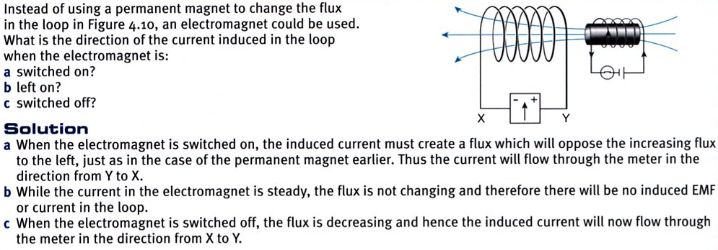
4. Coil pulled out of a field.

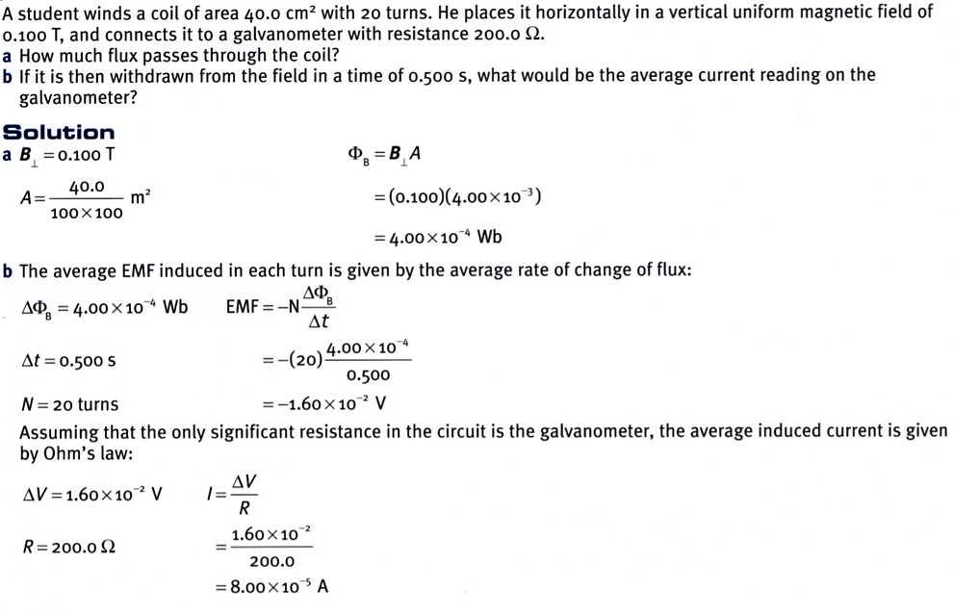

5. Coil in a field.

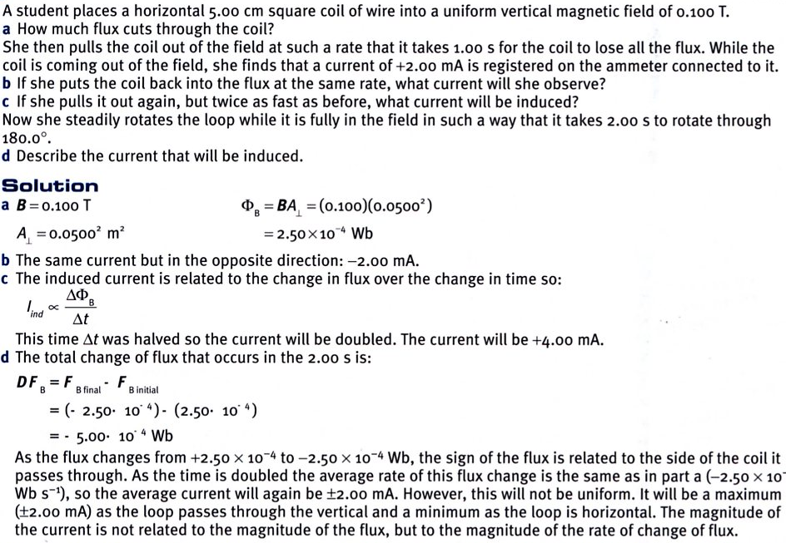
Applications

Superconductors
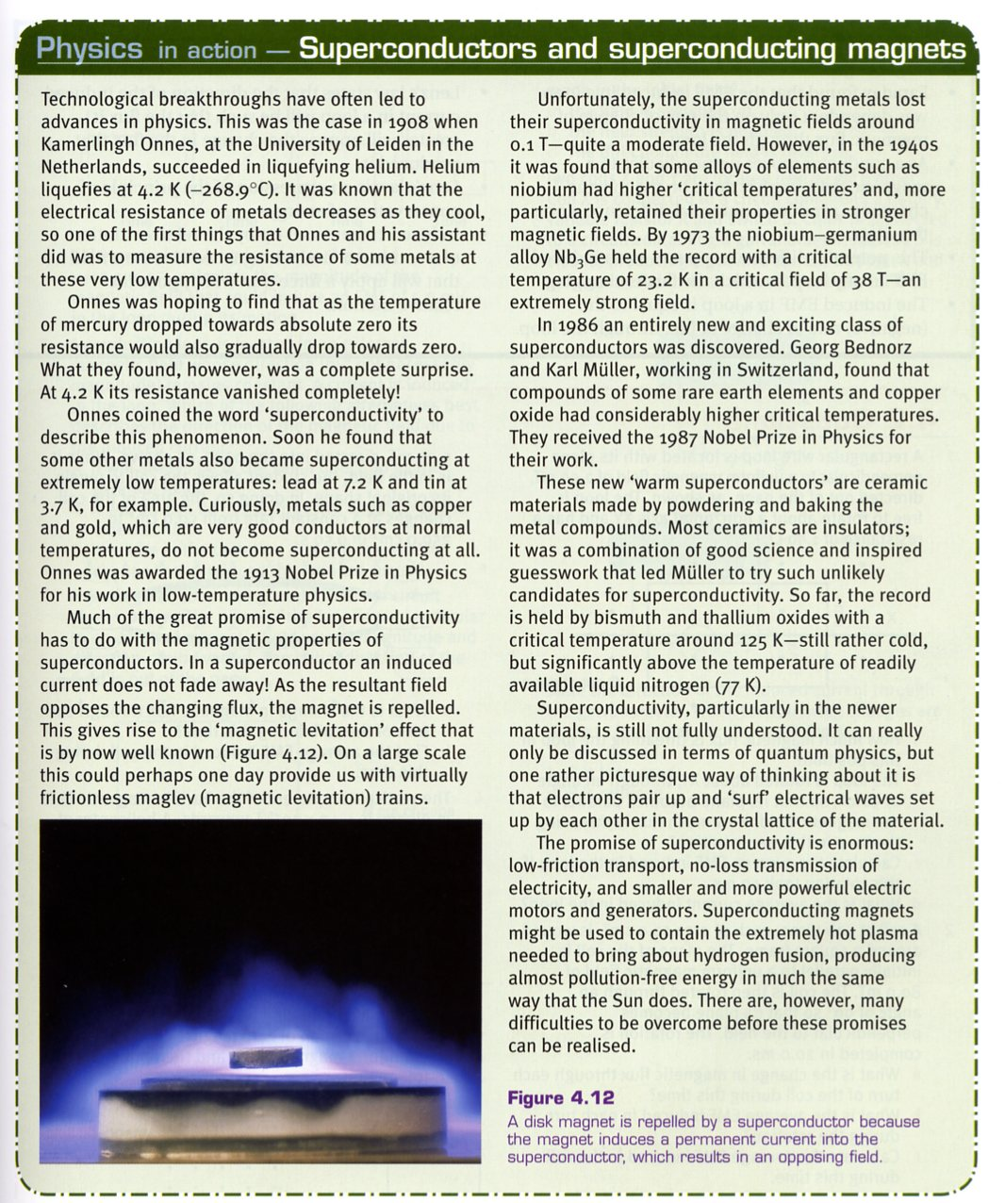

Maglev Trains

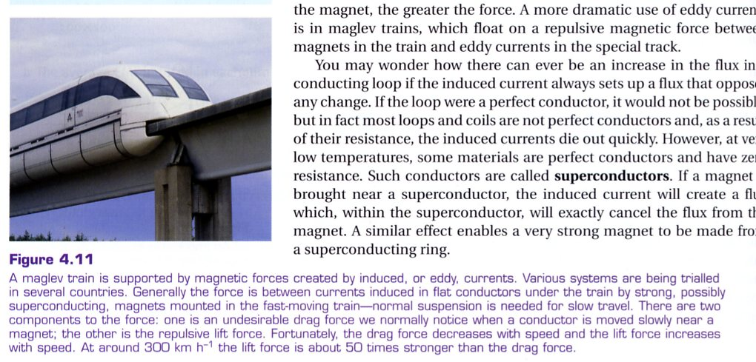

THE GENERATOR

Alternating Current (A.C.)

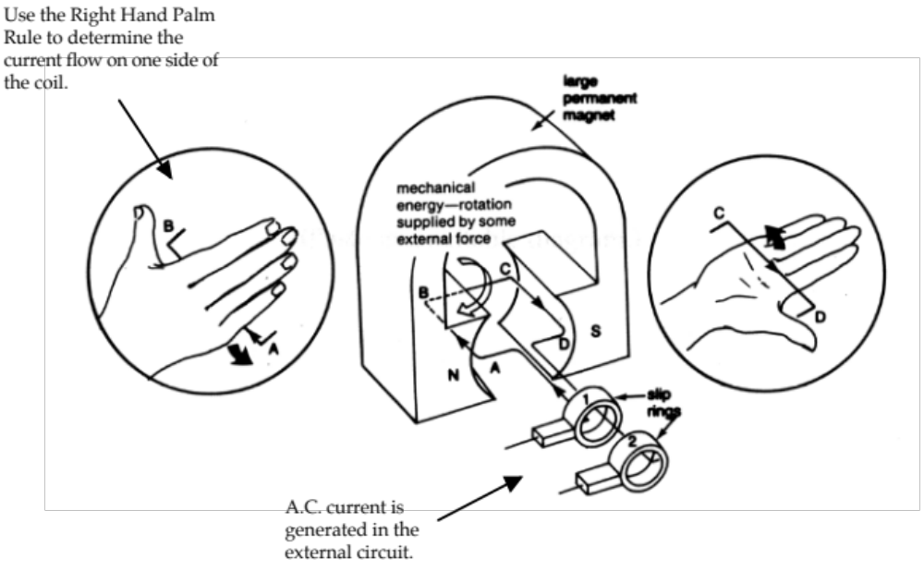

In generators, the coil is turned mechanically (by steam, wind, water or a small petrol/diesel motor).

This induces an EMF that will produce a current flow if the coil is part of a complete circuit.

In the A.C. generator (as seen before), the maximum EMF occurs when the sides of the coil are cutting the magnetic field at right angles (when the plane of the coil is parallel to the field) and it drops to zero 1/4 of a turn later when the sides of the coil are moving parallel to the magnetic field.

Every half a turn, the EMF will return to its maximum value but the induced current direction will be reversed.
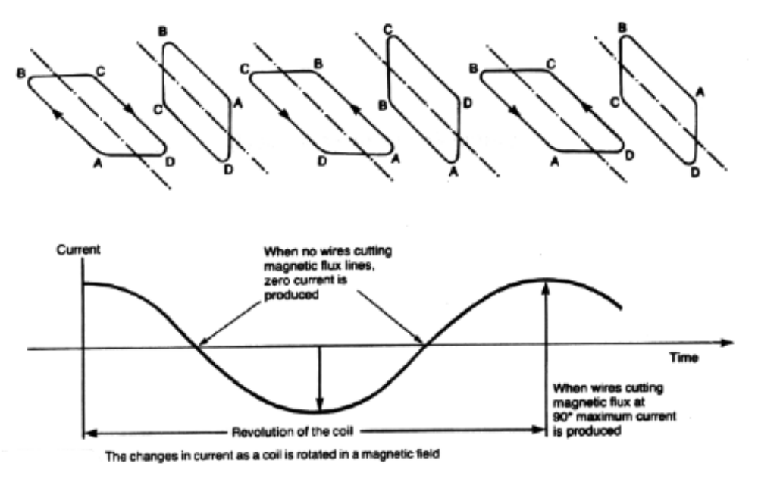

Due to the current reversing direction every half a turn, two slip rings or commutators are used to remove the induced current from the coil.

In power stations, the generators operate at 3000 r.p.m. which equates to a frequency of 50 Hz. Hence our power supply has its current direction changing 50 times each second.

Direct Current (D.C.)
Direct current generators work on the same principle except that a split-ring commutator is used to maintain the direction of flow of current from the coil in one direction.

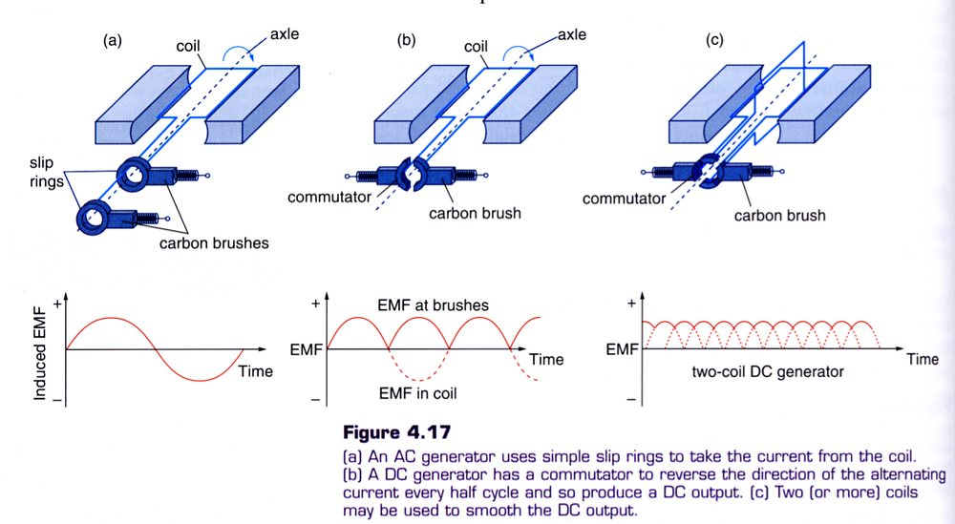

TRANSFORMERS

From Faraday’s formula:

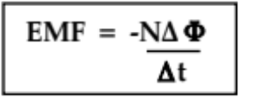

it is possible to produce an induced EMF not only by having a conductor or coil moving in a constant magnetic field, but also to have the conductor stationary in a changing magnetic field. This is the principle behind the operation of a transformer.

The structure of a transformer is as follows.

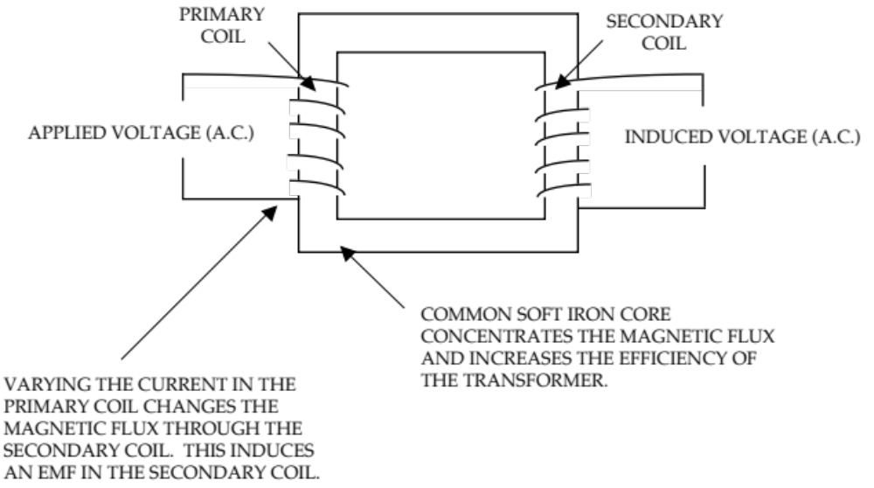

The easiest way to alter the current in the primary coil is to use AC current that constantly changes direction.

This induces an AC current in the secondary coil.

i.e. The secondary coil is stationary in a changing magnetic field.

From the current sine wave produced by an A.C. generator, the current is changing at its maximum rate as it passes through zero while changing direction.

In the transformer, this corresponds to the maximum change in the magnetic field associated with the current in the primary coil.

Consequently the EMF induced in the secondary coil is at a maximum at this time.

i.e. There is a 90° phase difference between the primary current and
secondary current.

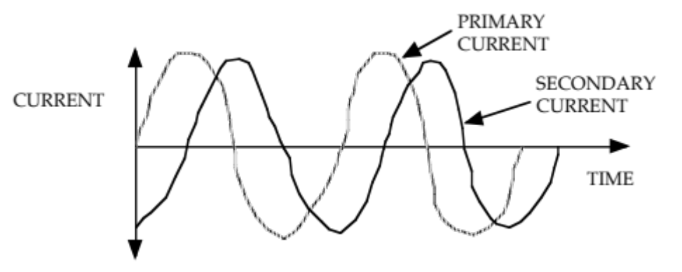

The relationship between the number of turns and voltages in the primary and secondary coils is given by:

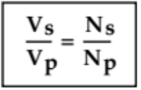

where V_{p} = voltage in the primary coil (V)
V_{s} = voltage in the secondary coil (V).
N_{p} = number of turns per unit length in the primary coil.
N_{s} = number of turns per unit length in the secondary coil.

Note
The use of DC current in the primary coil will not induce an EMF in the secondary coil since the magnetic field will not change.

From the above equation, the following is true.

STEP-UP TRANSFORMER: N_{s} > N_{p} so V_{s} > V_{p}

STEP-DOWN TRANSFORMER: N_{s} < N_{p} so V_{s} < V_{p}

For a transformer, the power dissipated in the primary coil is essentially equal to the power delivered to the secondary coil.

i.e. For calculations, transformers are assumed to be 100 % efficient.

From this can be calculated:

P (primary) = P (secondary)

=> VpIp = VsIs

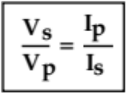

Hence the relationships within a transformer can be summarised as follows.

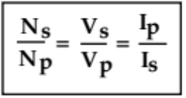

Thus when voltage is stepped up, the current is stepped down, and there is no power gain as a result of transformer action.

As with all machines there is some energy loss.

(See notes on Power Output.)

Example 1
A transformer has a primary winding of 200 turns that carries a current of 5.00 A at an input voltage of 48.0 V. The secondary winding has 50 turns.

(a) Calculate the voltage output from the transformer.
(b) Assuming the transformer to be 100% efficient, what is the power output of the transformer?

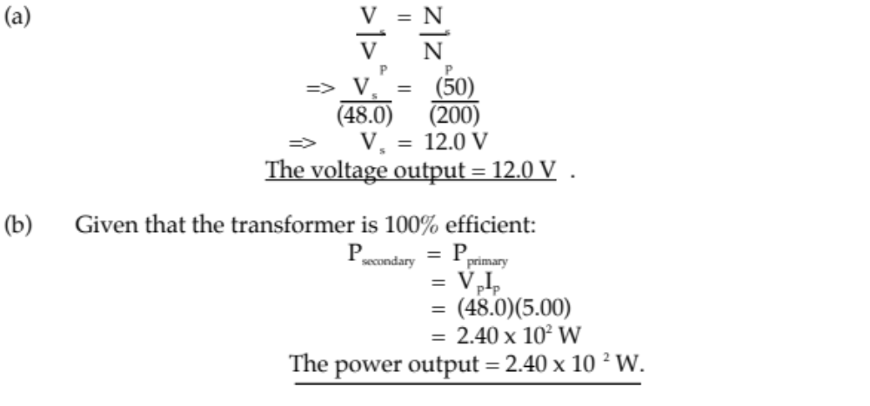
Example 2

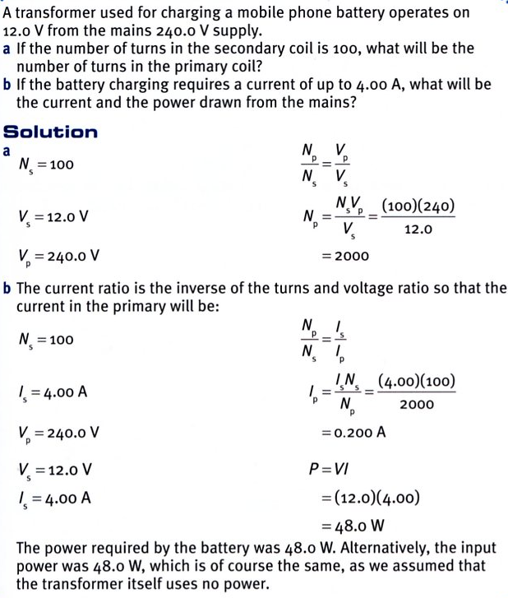
Power Output
Good quality transformers are usually 98-99 % efficient with 1-2 % of the energy being wasted as heat.

For this reason, electrical appliances that involve a transformer (e.g. TV, computer screens, CRO) are ventilated at the rear so this “lost heat” can escape from the machine and not cause any damage due to heat build-up.

The two main reasons for these heat losses are as follows
.
(a) Copper losses - the resistance of the copper wires in the primary and secondary coils
cause heat losses according to the formula P = I²R.

(b) Eddy current losses - as explained below.

Example
A step-down transformer has 100 turns in its primary coil and 25 turns in its secondary coil. The power of the transformer is 3.00 W and the voltage output is 6.00 V.

(a) Calculate the current in the primary coil.
(b) Explain which coil will have the thickest wire and why.

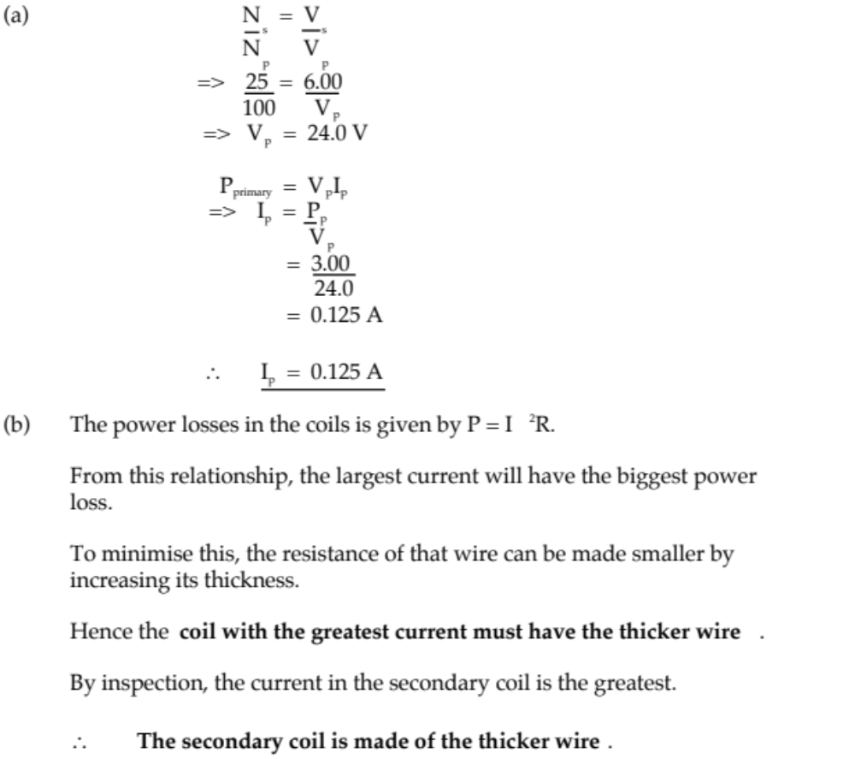
Eddy Currents

These are circulating currents of electricity that can be set up in conductors (particularly if they are large and plate-like) either moving in a constant magnetic field or stationary in a changing magnetic field.

These induced currents are closed loops that circulate in planes perpendicular to the magnetic flux.

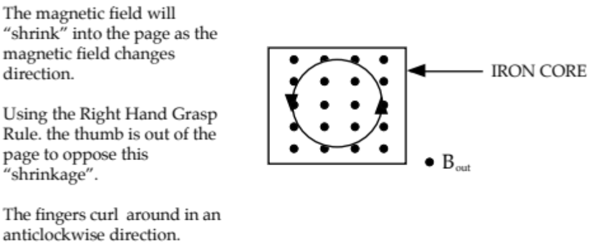

Eddy currents will produce a magnetic field that will cause a force to oppose the motion inducing the EMF (in motors and generators) and/or dissipate energy as heat (in transformers or electromagnetic braking systems).

Transformers have laminated iron cores (made up of thin sheets) to minimise the eddy currents produced. Thus the amount of heat generated is small.

The planes of these laminations are set in planes parallel to the magnetic flux so that the eddy currents are confined to the width of the individual laminations.

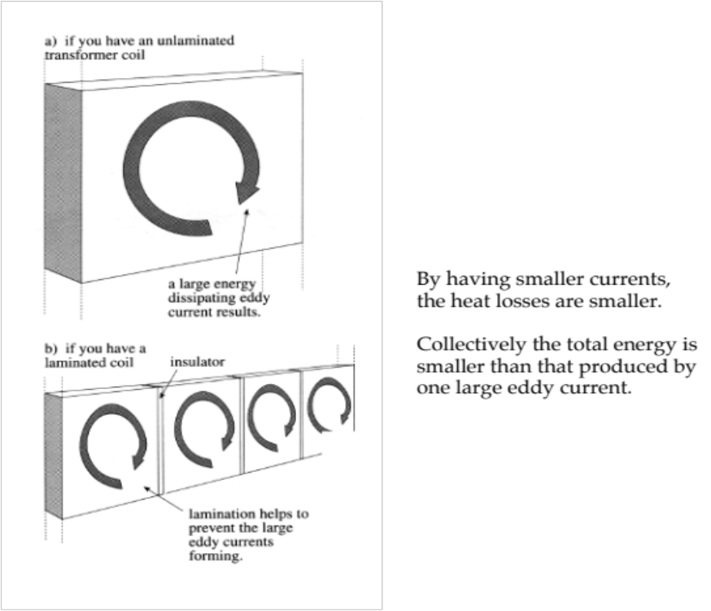
Magnetic braking systems rely on the production of large eddy currents so that their magnetic fields can interact with the permanent magnetic field present to oppose the motion of the metal brake disc and slow the vehicle.

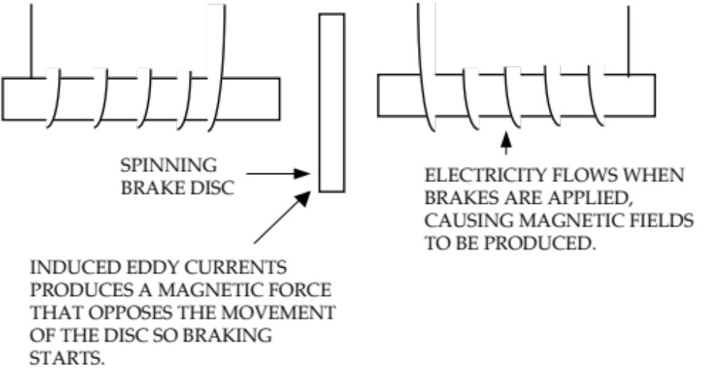

As the eddy current is large, large amounts of heat are generated in these braking systems.

Application

Three-phase Electricity

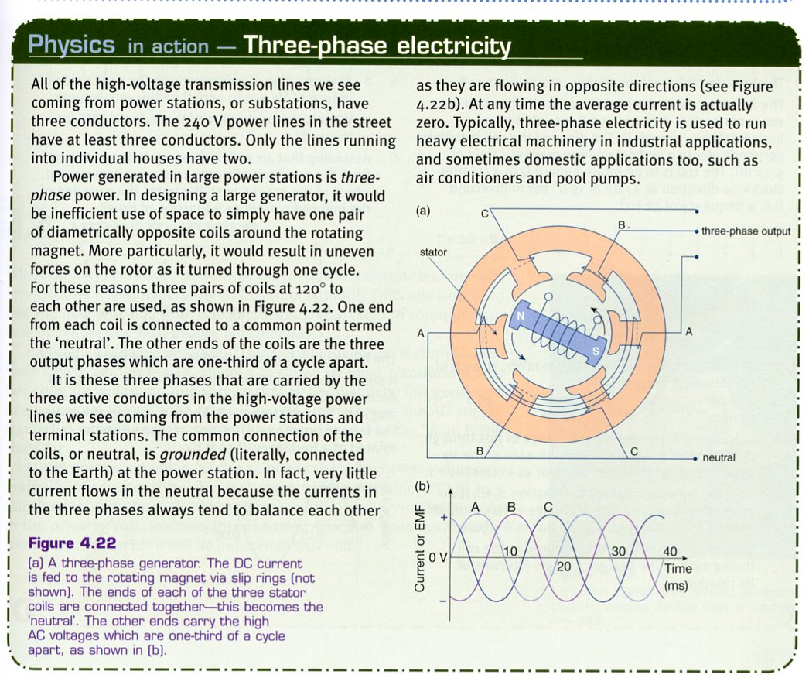
POWER TRANSMISSION

Domestic electricity is Australia is usually generated a great distance from the areas of greatest demand within large population areas.

e.g. Muja power station near Collie supplies the majority of electricity to the Perth
metropolitan area some 200 km away.

Due to the great distances involved, there is a large amount of resistance within the transmission lines. The movement of current through this resistance will cause a heating effect and hence a loss of energy.

The aim is to minimise this heat loss from the grid system by having as low a current as possible flowing.

From Year 11 work, the power produced by a current is given by:

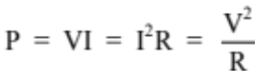

The power produced in a generator at a power station can be considered to be constant.

From P = VI, in order to have a small current, V must be high.

Hence the output voltage from a power station is usually stepped-up to 330 kV or 500 kV, then stepped-down as it reaches the areas where it is needed.

Note
From P = I²R, it can be seen that the power loss in the system is proportional to I².

The smaller I is, the smaller the power loss due to heat.

From P = VI:

every 10-fold increase in V means a 10-fold decrease in I (since the power P remains
constant).

=> a 100-fold decrease in the power loss P (since P = I²R).

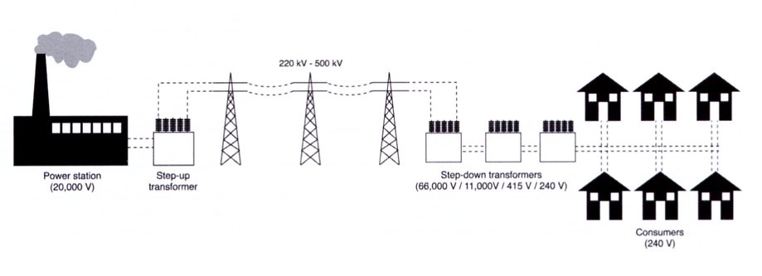
ENVIRONMENTAL IMPACT OF ELECTRICITY PRODUCTION AND TRANSMISSION

In Australia, most electricity is generated by burning coal (other sources are burning gas, hydroelectric schemes, wind power and solar cells).

The burning of coal is not very efficient as a lot of heat (≈ 50 %) is wasted. This leads to thermal pollution of the air and water streams that are used to produce the steam to drive the turbine generators.

Gases from the burning of coal (CO₂, SO₂, oxides of nitrogen) add to the air pollution problems in the atmosphere. Not only do they contribute to the Greenhouse Effect, they can all form acid rain by dissolving into rainwater. This acid solution has killed large areas of forest and crops in North America and Europe, chemically erodes buildings and statues by reacting with the stone, and killed aquatic life in lakes and streams. SO₂ and the oxides of nitrogen are also irritants to the respiratory system and cause problems for the elderly and asthmatics.

The pylons used to hold transmission lines need to be large and strong by necessity. However, they are a form of visual pollution for many people.

Due to the high current that flows (≈ 600 A), a strong electromagnetic field is produced. There has been some concern in recent times that people living near these lines are more prone to certain types of cancers. The research into this area is continuing.

The very high voltages used in transmission cause an atmospheric effect called corona phenomena. The air breaks down around the conductors and conducts with a voltage gradient of 800 Vmm⁻¹ of air. Hence the lines are kept at least 700 mm from the pylons by insulators to avoid arcing.

This air leakage creates additional power losses and affects TV, cellular phone and radio communications, causes visual coronas and audible crackling. Such effects are most prevalent when the air is moist.

CALCULATIONS INVOLVING POWER

The equations that are used are:

When considering calculations involving power from a power station, remember that:

1. the power of the individual generators add together to give the overall power output.
e.g. four generators each of 15.0 MW will produce 60.0 MW output.

2. the power output from the station is determined by the power used by each of the
houses, factories, buildings, etc. on the grid system.

Example 1
A power station generator, rated at 65.0 MW, produces a voltage of 11.0 kV that is stepped-up to 5.00 x 10² kV. The grid system for that area has a combined resistance of 6.00 Ω. Calculate:

(a) the current induced in the secondary coil of the transformer.
(b) the current produced in the grid system.
(c) the power loss that occurs in the grid system.
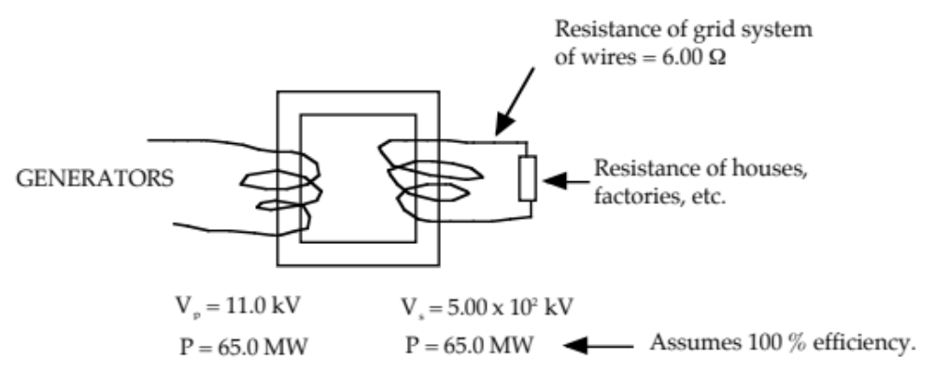

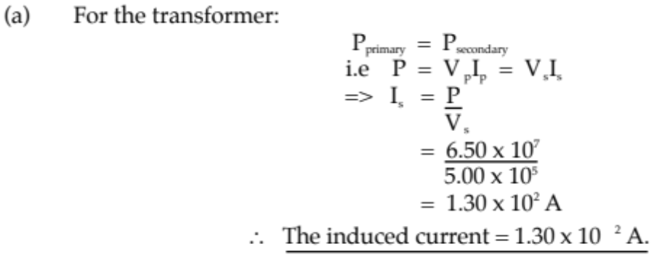
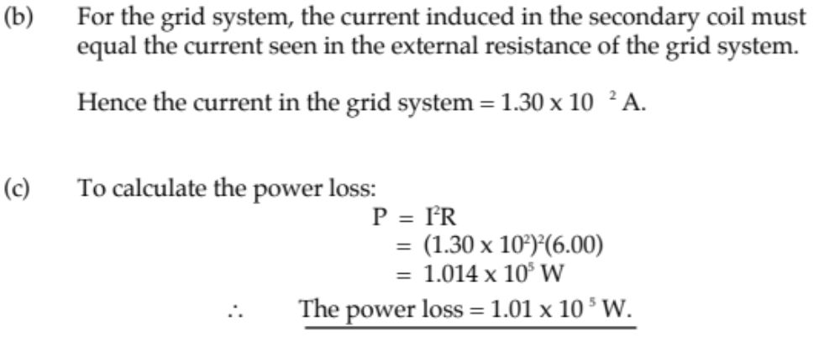

Note
The above calculations are very simplistic and really only apply to D.C. current.

A.C. current is much more easily generated and transformed, so it is the preferred current. This means that power losses are really due to impedance and inductance in the grid system. Calculations based on these concepts are difficult to understand and so have been avoided!

Example 2
A power station sends electricity through power lines 1.00 x 10² km long and resistance
2.20 x 10⁻³ Ωkm⁻¹ to a sub-station. Here 297 kV is stepped-down to 66.0 kV for transmission to a large part of the metropolitan area. The total resistance of this area (transmission wires, homes, factories, etc.) is 3.20 Ω.

(a) Calculate the power used by the area serviced by the sub-station.
(b) Determine the power loss occurring along the transmission lines between the sub-station and
the power station.
(c) Calculate the power required to be generated by the power station.
(d) What would happen if the total power required by the metropolitan area was greater than the
maximum that could be generated by the power station?

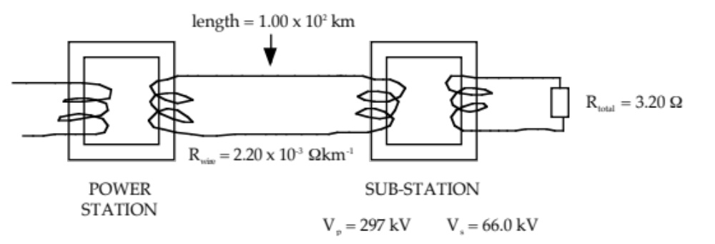

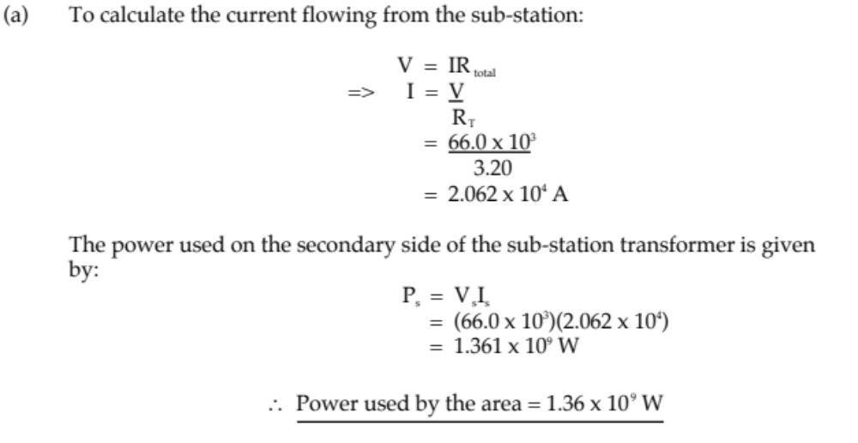

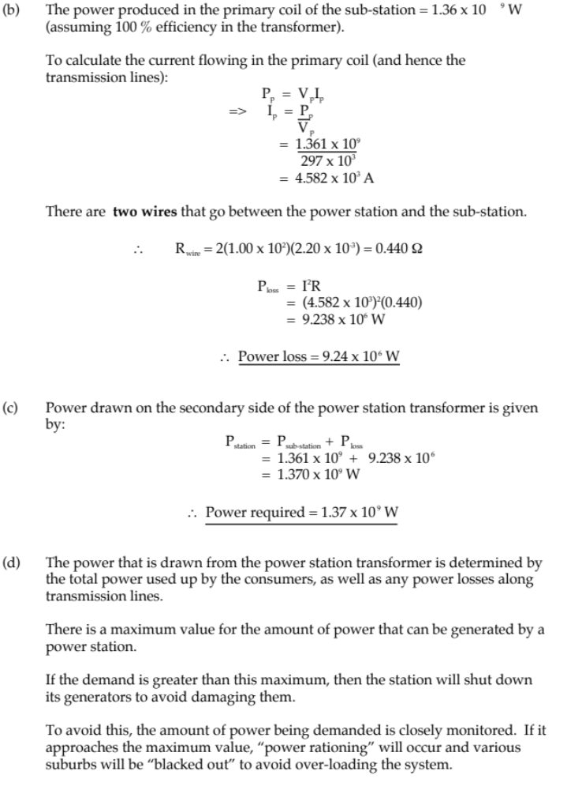

Example 3

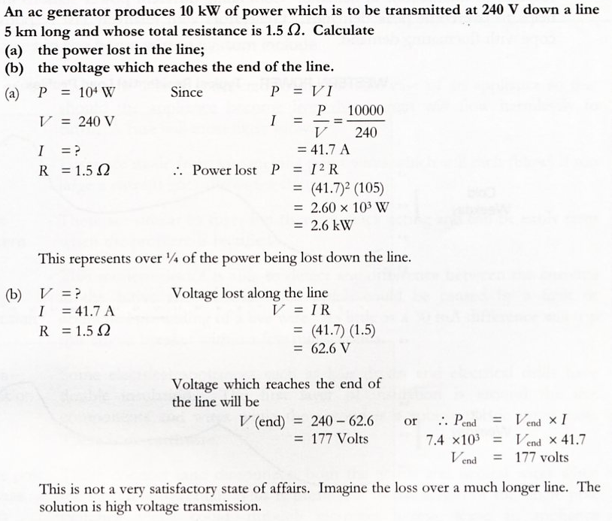

Example 4

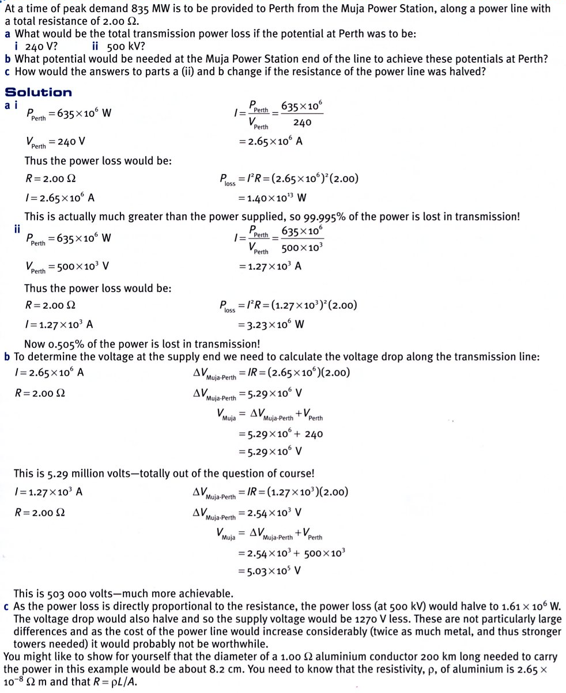

Applications

High-voltage DC

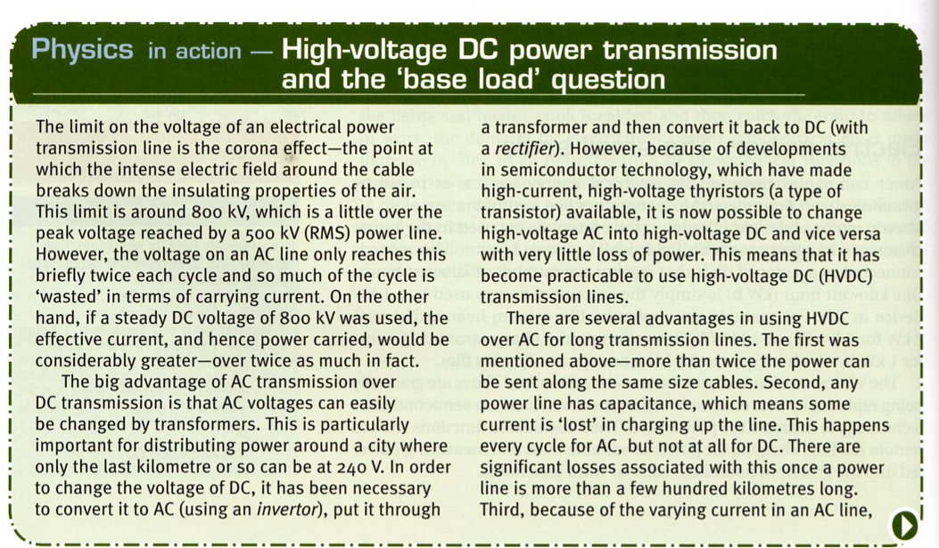

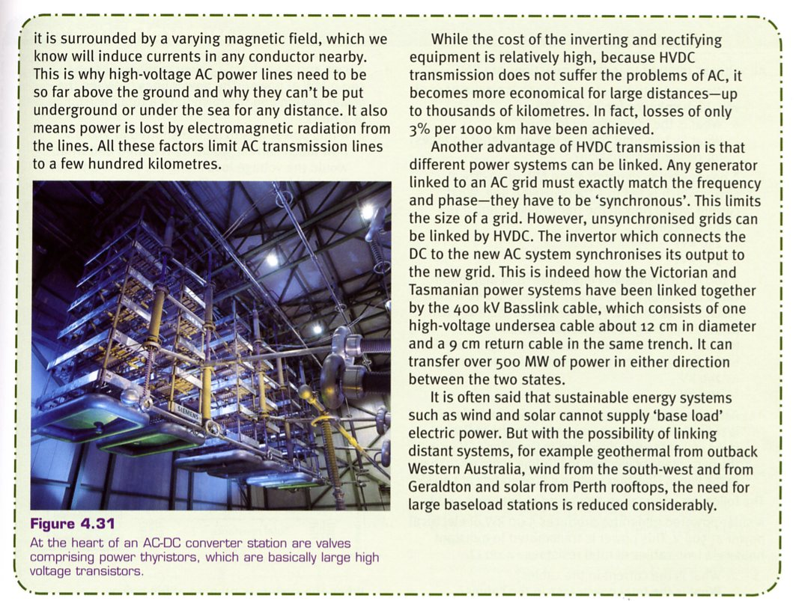
Safety - RCD Device

